User's Instructions
- Preparing host environment. Base on Freescale Yocto Project User's Guide.
First, make sure your host PC has the required packages to run Yocto.

- Download the source code. The following User's Guide, download Freescale Yocto Project Community BSP recipe layers to fsl-release-bsp.
$ mkdir fsl-release-bsp
$ cd fsl-release-bsp
$ repo init -u git://git.freescale.com/imx/fsl-arm-yocto-bsp.git -b imx-4.1.15-1.0.0_ga
$ repo sync

- Patching a board configurations to sources.
$ cp 0001_sources.patch .
$ patch -p0 < 0001_sources.patch

- Build configurations.
$ DISTRO=fsl-adlink-abb MACHINE=imx6dl-adlink-abb source fsl-setup-release.sh -b build-adlink

- Building an image.
bitbake fsl-image-abb

- For the images generated, you will find something at build-adlink/tmp/deploy/images/imx6dl-adlink-abb/ .
uImage is the latest kernel image.
u-boot is the latest u-boot image.
The .tar.bz2 file is the tarball for the rootfs, you can extract it on your PC.

- Deploy
deploy the sdcard image,
$ sudo mount /dev/sdX1 /mnt/card
$ sudo tar xf rtx-image-adlink-imx6dl-adlink-abb.tar.bz2 -C /mnt/card
deploy only kernel,
$ sudo dd if=uImage-imx6dl-adlink-abb.bin of=/dev/sdX bs=512 seek=26624
deploy only dtb,
$ sudo dd if=uImage-imx6dl-rtx-adlink.dtb of=/dev/sdX bs=512 seek=25600
deploy only u-boot,
sudo dd if=u-boot.imx of=/dev/sdX bs=512 seek=2
reset u-boot parameter to default,
$sudo dd if=/dev/zero of=/dev/sdX bs=512 seek=24576 count=10

- Start up system
Plug your sdcard and let the board boot
U-boot start up as bellow. If you want to change U-boot environment variables , please press “Tab” key.
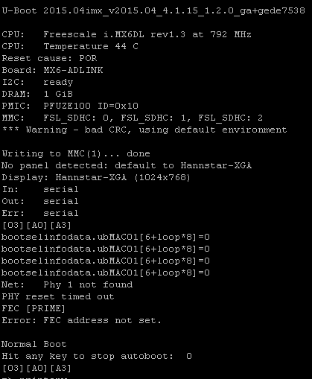

login: root

